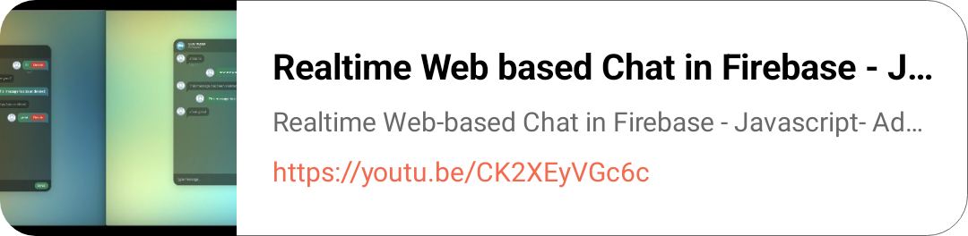

create message app android on websites
using reactjs

